1. How to user total cmd interface
1.1 Ctrl f1 or (f2,f3,f4,f5,f6) i.e basic linux without GUI
1.2 Ctrl f7 to get GUI session

2. How to see the list of processes running in your system
2.1 ps ax

3. How to kill a process in running in your system
3.1 kill -9 3126(processid)

4. How to see the percentage of CPU, Memory utilization
4.1 By using application htop

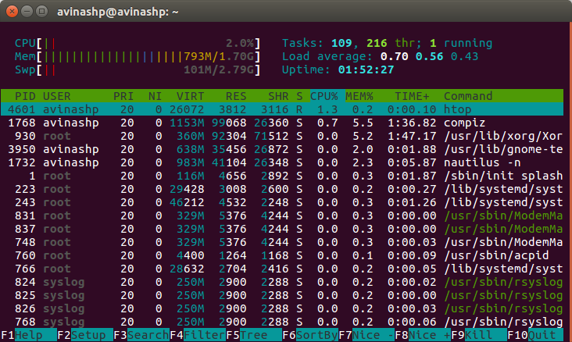

5. How to connect to a Remote Desktop

5.1 Using software in system i.e Remmina remote desktop client
5.1.1 select new
5.1.2 protocol is Virtual Network Computing
5.1.2 server is ip of system you want to connect 172.27.35.64

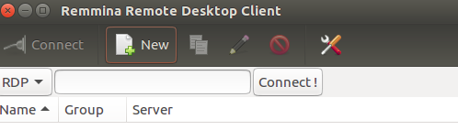

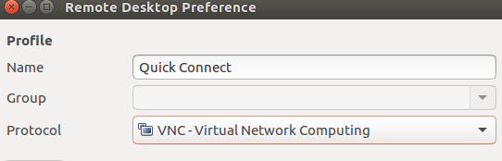

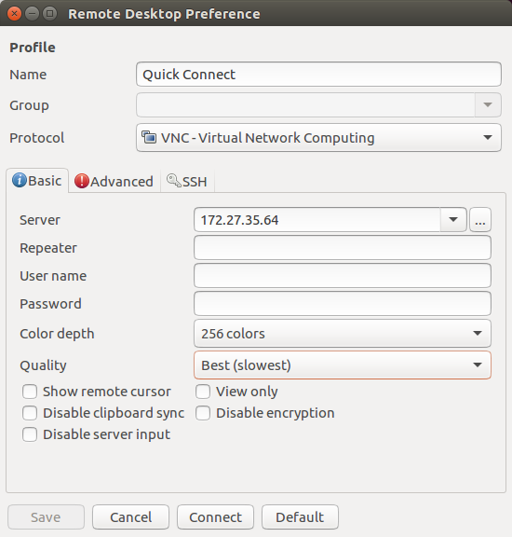

5.2 How to connect to a Remote Desktop (using ssh)
How to connect using ssh

5.2.1 ssh username@172.27.35.62

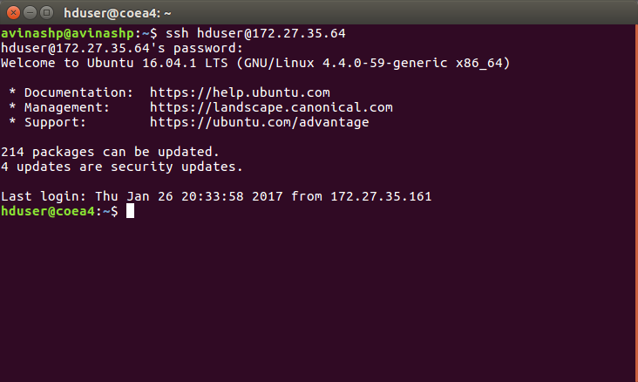

6. How to transfer file
6.1 Using scp

6.1.1 scp file you want to send other system username @ ip address collon : output file name

scp www11triangles.pdf hduser@172.27.35.64:mmt
6.1.2 password of other system

6.13 When copying file from remote host to local host
scp nagesh@218.248.13.232:/home/nagesh/TD/tweets.tar.gz ~/tweets.tar.gz

7. How to get superuser with all permissions ?
sudo nautilus

8. How to edit bashrc file ?
gedit ~/.bashrc

9. How to mount or give access to drive ?

sudo ntfsfix /dev/sda3
i.e sudo ntfsfix/path of the drive

10. How to view some set of records from a large file

head -1000 dblp.xml

11. what is tmux? How to use tmux?

To split the terminal into windows.
Commands used:
1. to get vertical split : ctrl + B + %
2. to get horizontal split : ctrl + B + “
3. to make use of a window : ctrl + B + O
4. to increase or decrease the size : ctrl + B + arrows

weblink: https://mutelight.org/practical-tmux

Example:
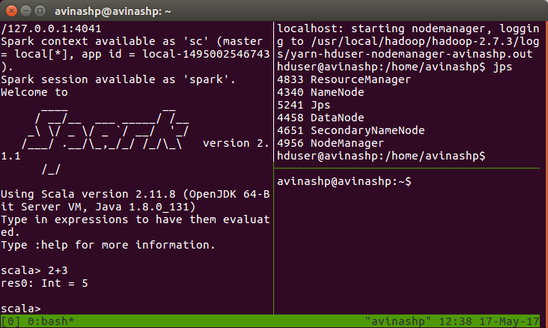

12. How to do Youtube downloads from cmd.
youtube-dl -f 18 youtubelink

13. tor browser

14. Google drive sync in Ubuntu

14.1 sudo add-apt-repository ppa:nilarimogard/webupd8
14.2 sudo apt-get update
14.3 sudo apt-get install grive
14.4 mkdir -p ~/grive
14.5 cd ~/grive
14.6 grive -a
14.7 copy and paste the link in browser and next paste the generated code to terminal.
14.8 TO SYNC from system to cloud
cd grive
grive sync
15. Unistall software in ubuntu
sudo apt purge softwarename
sudo apt purge ant

16. SEARCH A FILE VIA TERMINAL
16.1. find . -name "filename"

16.2. find . -name "New*" (* gives any thing after that)

17. SEE THE PROCESSES RUNNING IN BACHGROUND
ps -A

18. Downloading Youtube Files
youtube-dl https://www.youtube.com/watch?v=RWyjdxiJfWk

